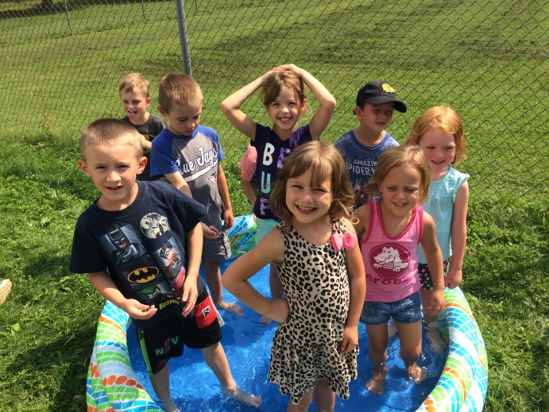

V.R.C Summer Day Camp

2021

**V.R.C Summer Day Camp Newsletter 2021**

Welcome to our summer day camp program at Vanastra Recreation Centre! We are excited to offer the Day Camp program this summer. We have been working very hard to meet Covid-19 safety requirements set by the Ontario Government. We ask that you are understanding and supportive of the enhanced health and safety guidelines or restriction that are in place. We all want to make this summer not only enjoyable, but safe for all. We will still fill your child’s day with fun games, crafts, swimming, and special events to engage all campers. Participation is mandatory because we want all campers to be involved and enjoy every activity to the fullest. As parents/guardians, we want you to take the role of encouraging your child(ren) to try new things and to make the most of their time here at day camp for themselves and those around them.

**What Should My Child(ren) Bring to Camp?**

All children grade 1 and above are required to wear a non-medical mask or face covering while inside and out doors if 2 meters cannot be maintained. We will be spending much of our days enjoying the summer sun, so please ensure that your child(ren) packs sunscreen, a hat, and a water bottle every single day! If you and your child(ren) could get into a habit of putting sunscreen on before even coming to camp that would be a huge help and is greatly appreciated. Your child should bring a lunch every day. We also have two snack breaks throughout the day; our first snack must be a nutritious snack. Every Monday, Wednesday, and Friday, we go swimming in the pool and on hot days we play water games, so ***please ensure that your child(ren) have a bathing suit and towel, and footwear that can get wet every day.*** Our program is designed to be active, so please ensure that your child(ren) have shoes that they can safely run, jump and climb with.

**Conflict Management**

It is our hope that we will all have a great summer and all our campers will enjoy every minute of it! However, there may be times that conflict arises. In this case, we will complete a behaviour form indicating what happened and the actions that were taken by our day camp staff. This form will be emailed to the child’s parent/guardian and to be returned via email in recognition of the conflict. If there are any problems that persist we may need to ask you to find alternative arrangements for your child. We want to ensure that this is a safe, enjoyable summer for all campers.

**Lost & Found**

We recommend that your child not bring expensive or valuable things to camp. Please ensure that your child understands that he/she is responsible for his/her belongings. If your child does feel the need to bring an electronic game, IPod, or cell phone, they will be asked to leave them in their backpacks until they have free time. If they are seen out during an unauthorized time they will be confiscated by a day camp leader until the end of the day. Please remember to label all valuables. **We are not responsible for any lost, stolen, or damaged items.**

**Day Camp Fees**

Our day camp fees and registration form can be found on our website at [www.huroneast.com](http://www.huroneast.com). Since we will be only offering limited space this year, there will be no daily rates available, only full week registration.

Day camp fees are paid upon registration by credit card. Please contact us if you need an alternate method of payment such as, e-transfers or cheque.

**Day Camp Dates and Hours**

Day camp will begin on July 5th and run through to August 27th. Day Camp hours are 8:00 am – 5:00 pm. Programs will start at 9:00 am and run through till 4:00 pm. Extended care is not available. Every ten minutes after 5:00 pm there will be a one-dollar charge if the child(ren) is still not picked up. Day Camp will be closed August 2 for the Civic holiday.

**Special Events Information**

This year our special events will take place here at the Vanastra Recreation Centre every other Thursday starting July 15th. There will be an extra charge on these special event days, we will do our best to keep it at a very nominal fee. If you have any questions regarding our special event days, please do not hesitate to ask one of our Day Camp staff.

**Climbing Wall**

At Day Camp we have a transverse rock climbing cube that is installed and remains in the gymnasium. The goal of our climbing wall is to innovate activity that captivates all learners and to build physical, cognitive, and social/emotional skills. Climbing develops cardiovascular fitness, strength, flexibility, and coordination. Climbing activities are integrated with emotional and intellectual characteristics such as problem solving, patience, perseverance and courage. Students will be supervised while using the climbing wall at all times. However, as with all climbing walls there is an element of risk involved. This being the case, we request that you fill out a letter of permission for your child(ren) to participate on the climbing wall. This permission form is **mandatory** for your child(ren) to participate in our activities on the climbing wall.

**Allergy Information**

Please make staff aware of any allergies your child(ren) may have (food, medication, other) if you require staff to administer medication to your child, you will be required to fill out an information and permission form. Please ask staff for details.

**Click!**

We will be taking pictures throughout the summer of the crafts, games, activities and day trips that your child(ren) will participate in. With your permission, we wold like to use some of these pictures next year when promoting our summer programs at Vanastra Recreation Centre. Please check the photo consent box attached in the newsletter if your child(ren) may be photographed.

If you have any further comments or questions, please feel free to reach out to a camp staff member. We are looking forward to a great summer with your child(ren)! See you at Day Camp!☺

Your Day Camp Leaders

Mackenzie

_________

_________

_________